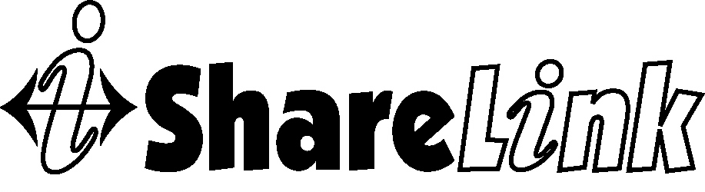
Agency use only:
File ID___________________________
Date ___________________________

Authorization for use and disclosure of protected health information
This form documents my permission for ___[Insert Agency Name]__ to share my ShareLink records, which contain information about me called “protected health information”, with other organizations that use the ShareLink system to exchange information. The purpose of sharing my ShareLink records is to help ShareLink organizations more quickly determine what services I need and whether I am eligible for those services by not having to collect the same information from me again, and to coordinate the delivery of services that are provided to me.
I understand that if I sign this consent/authorization and information is disclosed to another agency, the information may lose protection it would otherwise have under Health Insurance Portability and Accountability Act (HIPAA - a federal law that protects certain health information about me). I further understand that each current and future participating ShareLink organization that will have access to my ShareLink records will have signed a written contract that promises they will only use my information for the purposes stated above and will not release it to anyone else.
I understand that if I do not sign this form, it will not change whether or not I can receive services from _[Insert Agency Name]__ or any other ShareLink organization.
I understand that this authorization is good for _____ [Designate 1 to 3] year(s) from the date of my signature below unless I withdraw it by giving a written request to _____[Insert Agency Name]__ _________, which I may do at any time. If I withdraw this authorization in the future, I understand that it will not change the fact that my ShareLink records were shared before that date.
I agree to allow ________[Insert Agency Name]____ to share my ShareLink records with people who work as employees, contractors, consultants or volunteers at the organizations that use the ShareLink system.
I understand that additional organizations may join ShareLink at any time and will also have access to my ShareLink records for the previously stated purpose of coordinating access and delivery of services to me. I understand that upon my request any ShareLink agency will furnish me with an updated copy of all participating agencies.
My ShareLink records may include information about me and my household such as name, address, employment, gender and age, about non-health services such as food, clothing, housing and financial assistance, about medical and mental health conditions, substance abuse treatment, and domestic violence issues that I currently have or have received treatment for in the past, and about services that I receive from ShareLink organizations.
Oklahoma law requires the following statement on this form: “Health information authorized for release may include records which may indicate the presence of a communicable or venereal disease which may include, but are not limited to, diseases such as hepatitis, syphilis, gonorrhea and the human immunodeficiency virus, also known as Acquired Immune Deficiency Syndrome (AIDS).”
I understand that if the records or information being released involve treatment for alcohol or substance addiction, my records are also protected by federal law and regulations relating to “confidentiality of alcohol or drug abuse patient records” (42 C.F.R. Part 2, 42 U.S.C. § 290dd-2).
If the records or information released involve treatment for alcohol or substance addiction, this information has been disclosed to agencies from records protected by federal confidentiality rules (42 C.F.R. Part 2). Federal rules prohibit agencies from making any further disclosure of this information unless further disclosure is expressly permitted by the written consent of the client to whom it pertains or as otherwise permitted by 42 C.F.R. Part 2. A general authorization for the release of medical or other information is not sufficient for this purpose. The Federal rules restrict any use of the information to criminally investigate or prosecute any patient/client for alcohol or drug abuse.
__________________________________
Name of Client (print) Date of Birth

__________________________________
Signature Date signed

For Parent, Guardian or Personal Representative of Client (if applicable)

__________________________________ ________________________
Signature Relationship to Client Date signed

